Sundial Winter Sale

Work remotely from the beach & enjoy the beautiful Gulf views all day long!
Extend your beach get-aways each year and relish the tranquility of the surroundings!
Surprise a loved one over the holidays with their own Beach Condo!

Sundial Owners Association is presenting a limited offer. From November 1, 2023, to December 31, 2023, purchase two weeks for the price of one. Purchase any two weeks during this Winter period and Sundial will waive the onetime purchase price and transfer fee on the second unit. The units that are available for sale are identified below:
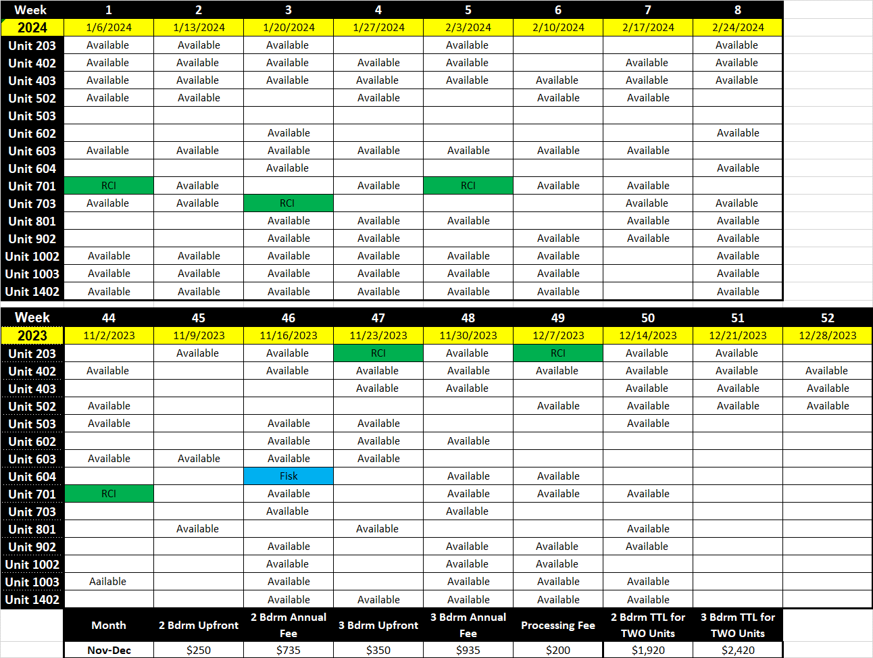

Contact the Sundial office at 361-749-6668 for more information.

