Ease into 2024 with this fantastic offer!
Book 3 nights Get the 4th Night Free!
Extend your beach get-aways this Winter and delight in the tranquility of the surroundings!
Come enjoy the BEST kept secret in South Texas & Make Sundial @ Mustang Towers your Beach Condo get-away this Winter

Sundial Owners Association is presenting a limited time offer. From January 13th, 2024, to May 5th, 2024, buy three nights and get the 4th night free. All rentals are on a first come basis. Available units are identified below:
- Two Bedroom Offer – 3 nights & the 4th night is free - $415.00
- Three Bedroom Offer - 3 nights & the 4th night is free - $580.00

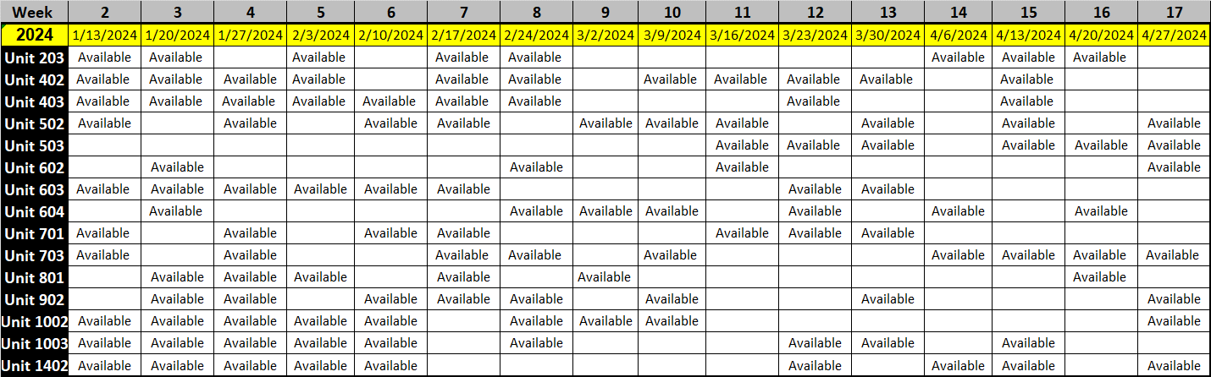

Contact the Sundial office at 361-749-6668 for more information.

