

**Sundial Peak-Season Sales & Rental List**

**Includes Spring Break, Memorial weekend, Labor Day weekend,**

**Thanksgiving and Christmas/New Year’s weeks**

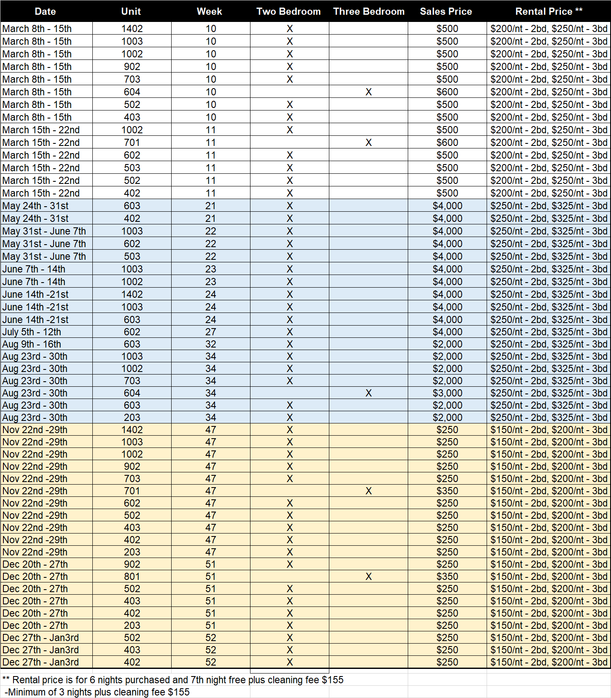

**Contact the Sundial office at 361-749-6668 for more information**

